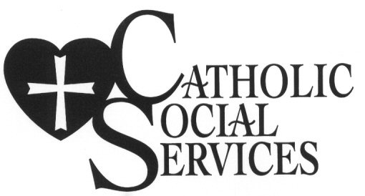

PRESS RELEASE 10-2-2019

Catholic Social Services Reaches Out
to Farm and Ranch Families in Western South Dakota

Catholic Social Services has been hearing from pastors, rural families, and local businesses that adverse weather conditions and low commodity prices are taking a toll on many local farm and ranch producers. Spring blizzards, record rain falls, flooding and low commodity prices are creating economic hardships for many in our region that pose a threaten to the viability of some operations. In response, Jim Kinyon, CSS Executive Director, approached the Diocese of Rapid City’s Disaster Response Committee. The committee has authorized the use of funds to offer farm and ranch families a listening ear.
According to Kinyon, “the CDC reports that farm and ranch families have the highest suicide rates among all professions. Too often these families feel as though they are on their own and haven’t had access to affordable or accessible services. Historically our rural regions have lacked access to basic services needed to help support them. Producers can become discouraged when weather and economic conditions they have little control over become chronic stressors.”
In order to reach out to address these realities, Catholic Social Services has made available free services throughout western South Dakota for producers. These services can be accessed either through CSS’s offices or via tele-therapy. To access tele-therapy call CSS’s office at 605- 348-6086. CSS’s only fulltime office is in Rapid City but services are also accessible through our satellite offices in Eagle Butte, Spearfish, Pine Ridge, or Porcupine.
(Please post the enclosed flyer on your bulletin boards and share with others in your community)

John Schmit, Communications Director
Catholic Social Services
529 Kansas City Street
Rapid City, SD 57701

